**CPU SCHEDULING**

CPU scheduling is an important feature of operating systems that determines the order in which processes are executed by the central processing unit (CPU). The goal of CPU scheduling is to optimise the utilisation of the CPU and enhance system performance.

Here are some key concepts related to CPU scheduling:

**Types of CPU Scheduling Algorithms:**

1. **First-Come-First-Serve (FCFS):**

- **Advantage**: Simple and easy to implement.

- **Drawback**:

* Can lead to the "convoy effect," where short processes get stuck waiting behind a long process.
* Can lead to inefficient use of CPU time, especially in the presence of long processes.

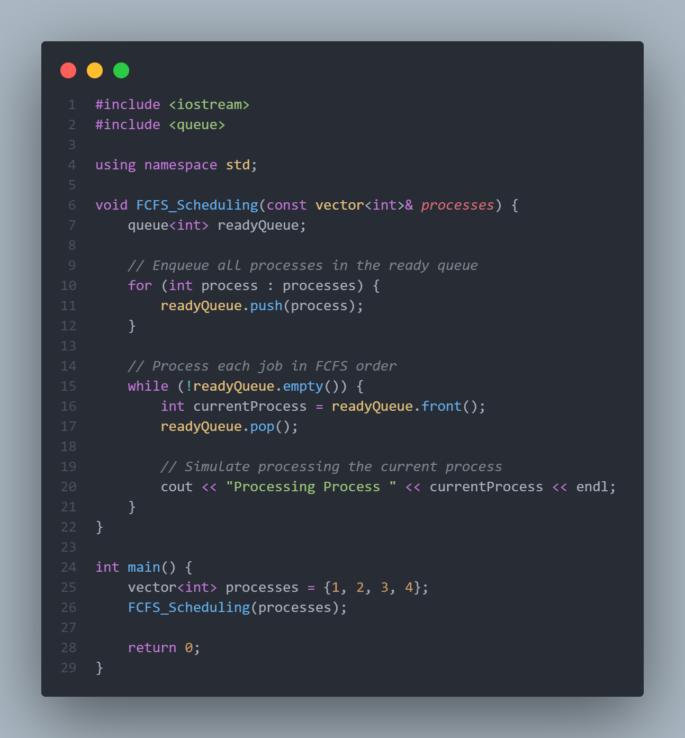

**2.** **Shortest Job Next (SJN) or Shortest Job First (SJF):**

- **Advantage**: Minimises waiting time and provides optimal throughput for a set of processes.

- **Drawback**: Requires knowledge of the total burst time, which is often not available in a real-time environment.

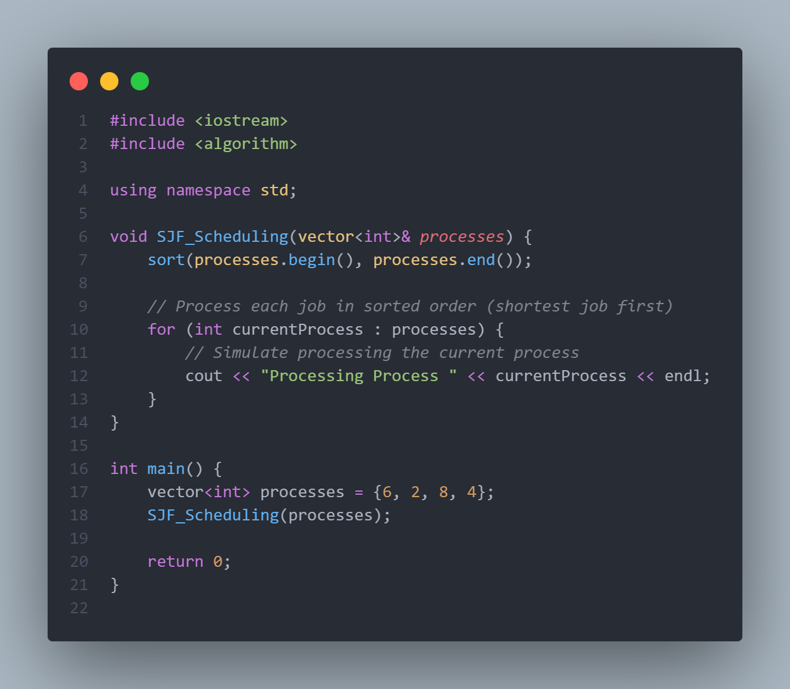

3. **Priority Scheduling**:

- **Advantage**: Allows assigning priority levels to processes based on various factors.

- **Drawback**: Can lead to starvation of low-priority processes if not implemented carefully.

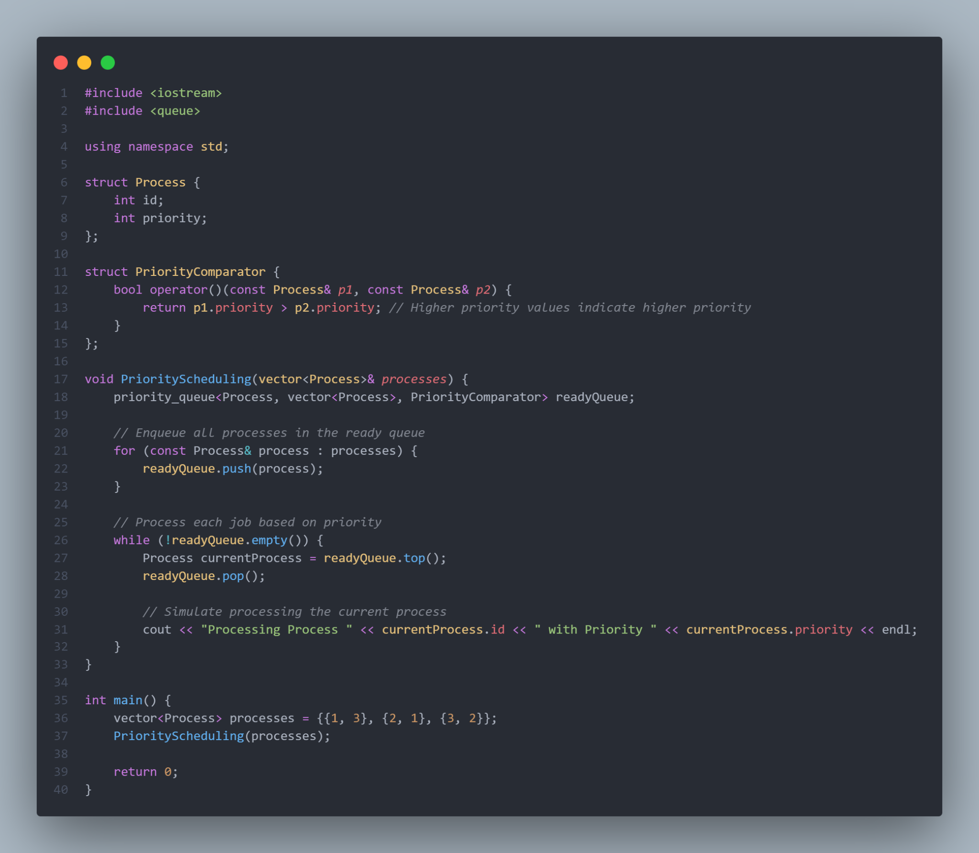

4. **Round Robin (RR):**

- **Advantage**: Fairness in terms of process execution; all processes get an equal share of the CPU.

- **Drawback**: High turnaround time for long processes, and the time quantum needs careful tuning.

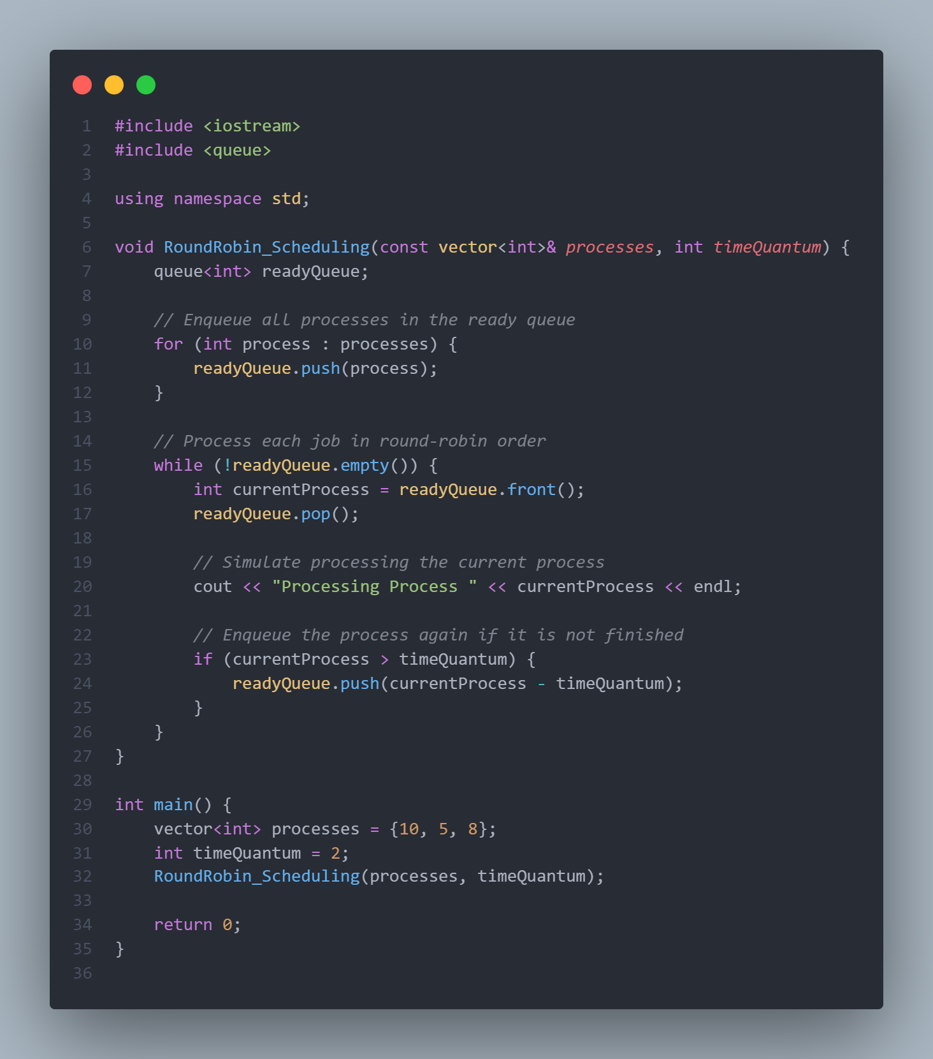

5. **Multilevel Queue Scheduling**:

- **Advantage**: Supports the division of processes into different priority levels, each with its own scheduling algorithm.

- **Drawback**: Complexity in managing multiple queues.

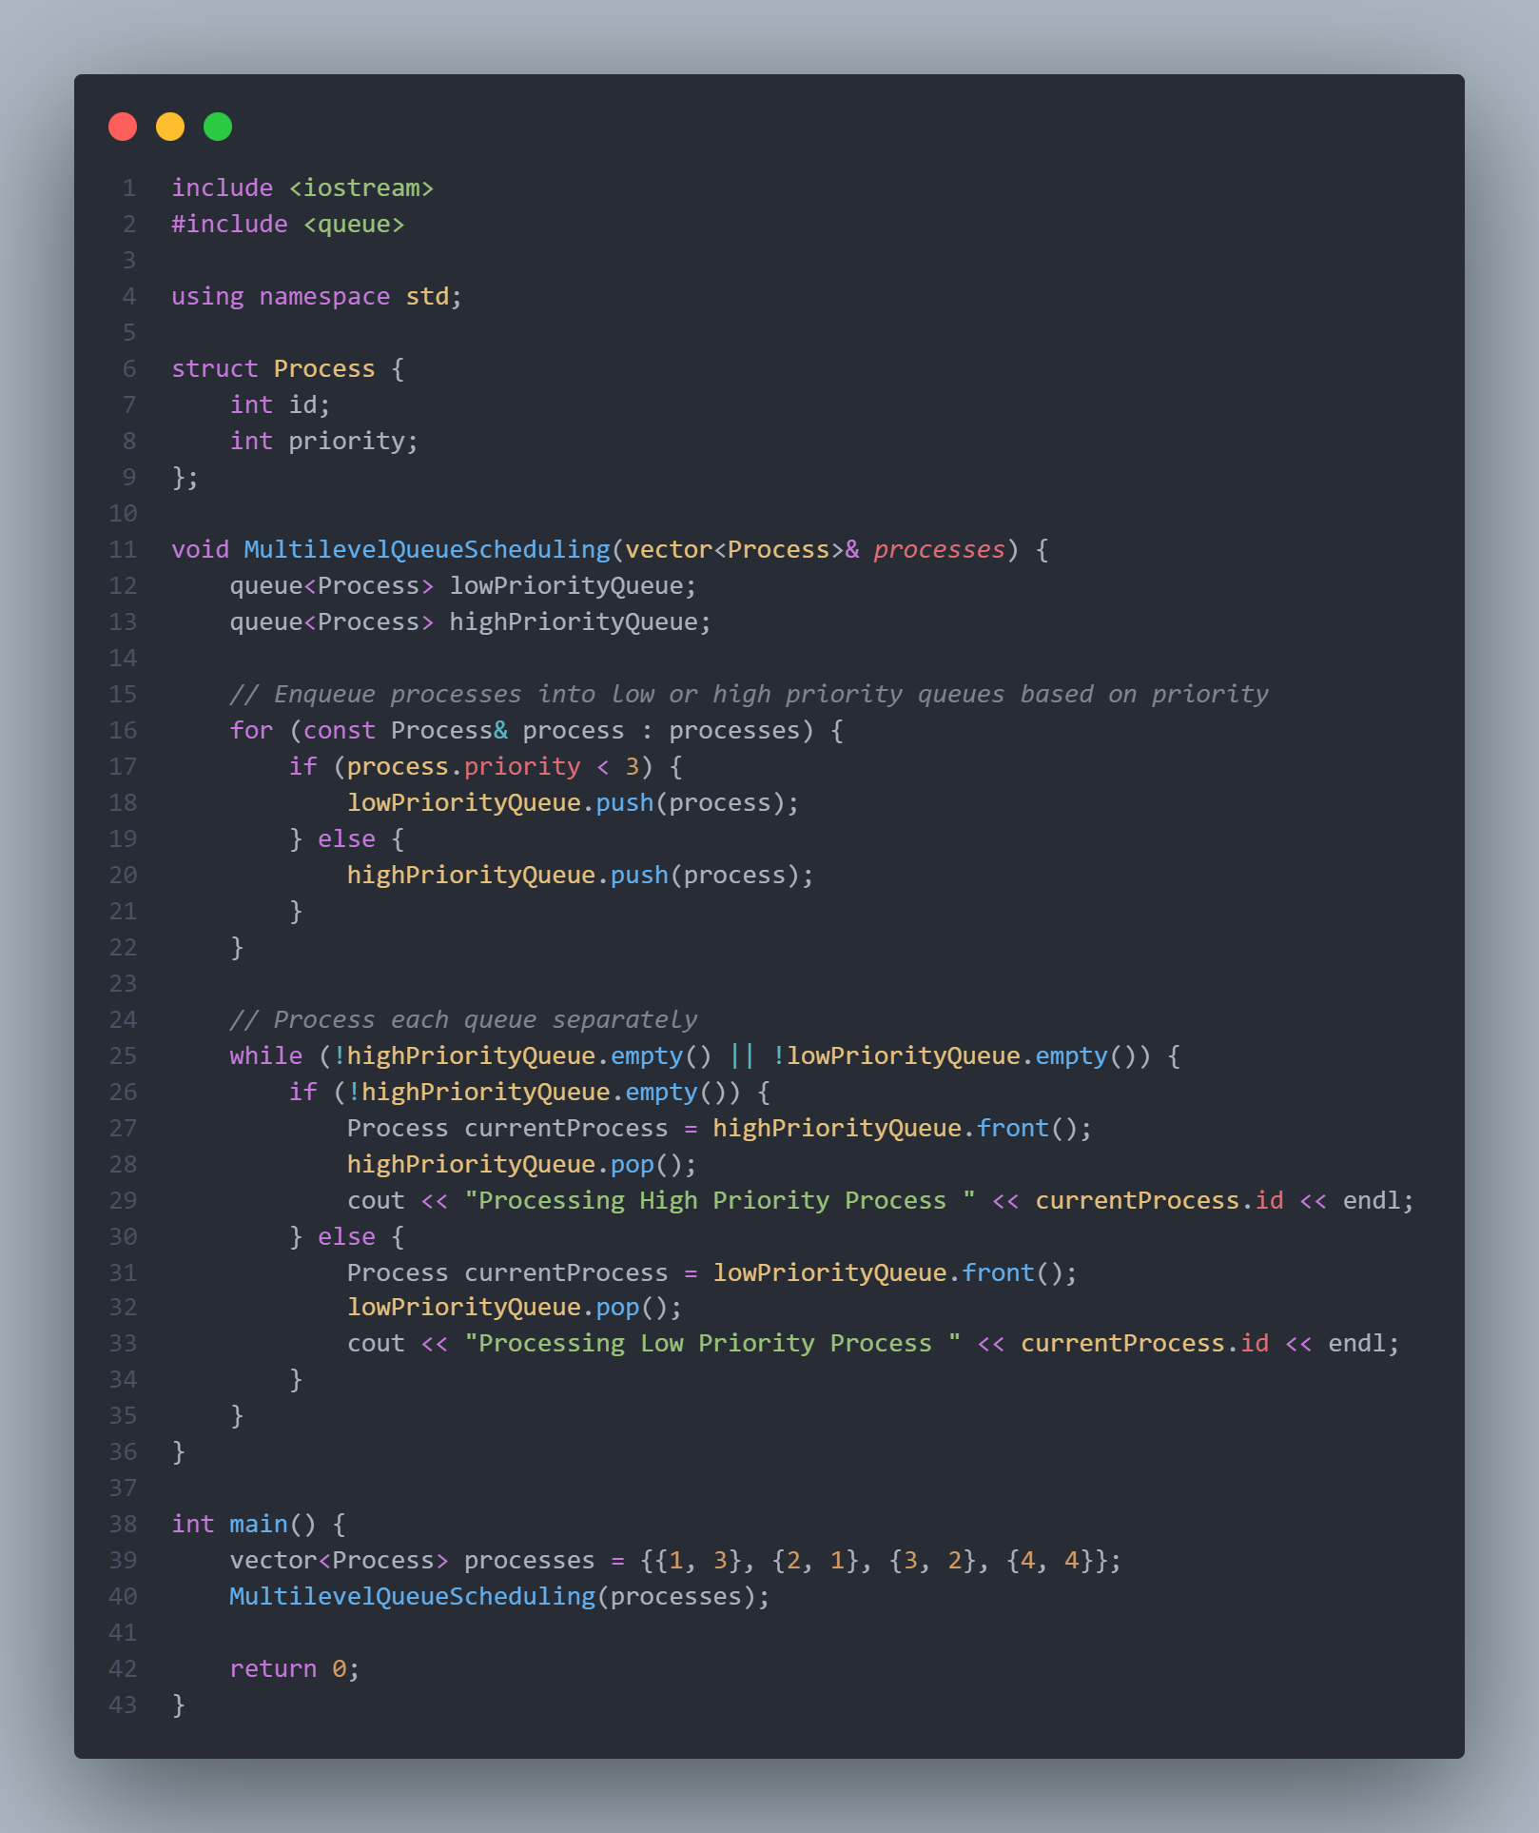

6. **Multilevel Feedback Queue Scheduling**:

- **Advantage**: Allows processes to move between different priority queues based on their behaviour.

- **Drawback**: Requires careful tuning of parameters to prevent processes from oscillating between queues.

